Assignment 5

Name – Abhishek Agrahari

Roll Number 190123066

Question 1

a)

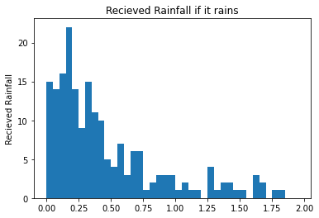

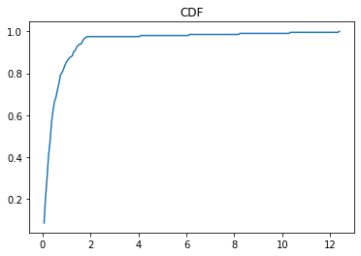

This histogram correspond to density 2\*e^(-2\*x)

CDF = 1-e^(-2\*x)

And 0.8 if x = 0

Algorithm –

Generate U1 as uniform [0,1]

Generate U2 as uniform [0,1]

If U1 <= 0.2:

X = -2\*log(U2)

Return X

b) Total rain = 129.1866

Average rain = 129.1866/1000 = 0.1291866

Question 2

Question 3

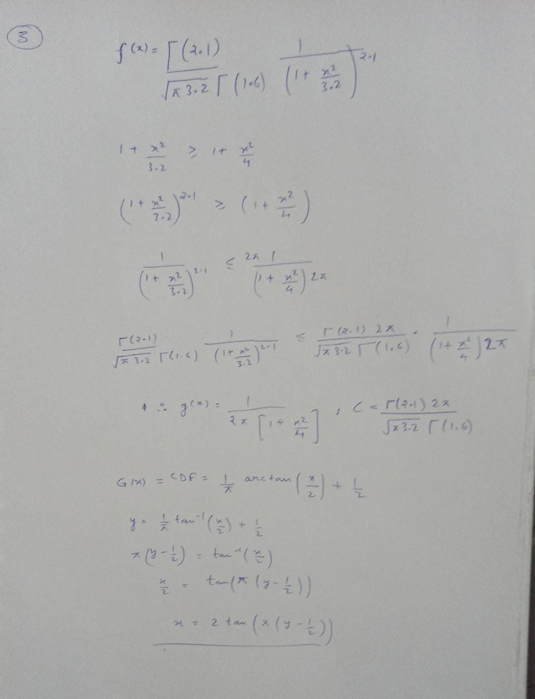

In the last inverse of CDF is shown.

b) acceptance probability = 0.43086

c) from sample= 0.6191

There will become more comparable for larger value of N